F.03 INTRODUCTION TO CNS DRUGS: DRUGS ACTING ON THE CNS
DR. JOHN HAROLD B. HIYADAN I NOVEMBER 6,2025
- ORGANIZATION OF THE CNS 1
- ION CHANNELS & NEUROTRANSMITTER RECEPTORS 2
- NATURAL TOXINS USED AS TOOLS FOR CHARACTERIZING ION CHANNELS 4
- SYNAPSE & SYNAPTIC POTENTIALS 5
- SITES OF DRUG ACTION 6
- CELLULAR ORGANIZATION OF THE BRAIN 7
- CENTRAL NEUROTRANSMITTER 8
- REFERENCES 13
- CHECKPOINT 13
‘
- ORGANIZATION OF THE CNS
- Composed of the brain and spinal cord and is responsible for integrating sensory information and generating motor output and other behaviors needed to successfully interact with the environment and enhance species survival.
- The human brain contains about 100 billion interconnected neurons and surrounded by various supporting glial cells.

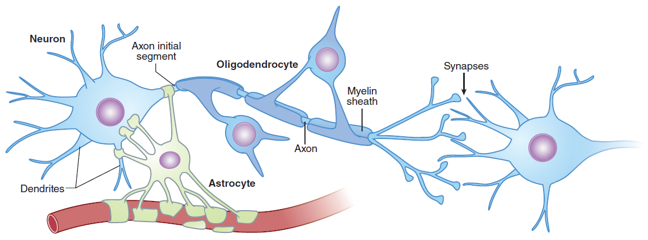
Figure 1. Neurons and glia in the CNS.

- NEURONS
- Electrically excitable cells that process and transmit information via an electrochemical process.
- There are many types of neurons and are classified in:
- By location
- By function
- By the neurotransmitter they release
- A typical neuron has a cell body (or soma) and specialized processes called dendrites and axon.
- A typical neuron has a cell body or soma that receives the synaptic responses from the dendritic tree.
- These synaptic responses are integrated at the axon initial segment, which has a high concentration of voltage-gated sodium channels.
- If an action potential is initiated, it propagates down the axon to the synaptic terminals, which contact other neurons.
- The axon of long-range projection neurons is insulated by a myelin sheath derived from specialized membrane processes of oligodendrocytes, analogous to the Schwann cells in the peripheral nervous system.
- Astrocytes perform supportive roles in the CNS, and their processes are closely associated with neuronal synapses.

A1. | DENDRITES
- From highly branched complex dendritic “trees”, receive and integrate the input from other neurons and conduct this information to the cell body.

A2. | AXON
- Carries the output signal of a neuron from the cell body, sometimes over long distances.
- Neurons have HUNDREDS OF DENDRITES but have ONLY ONE AXON.
- Axon terminals make contact with other neurons at specialized junctions called synapses where neurotransmitter chemicals are released and interact with receptors on other neurons.

- NEUROGLIA
- Large number of non-neuronal support cells called glia that perform a variety of essential functions in the CNS.

B1. | ASTROCYTES
- Most abundant cell in the brain and play homeostatic support roles including metabolic nutrient to neurons and maintaining extracellular ion concentrations.
- Involved in the removal and recycling of neurotransmitters after release.
- Play increasingly recognized active roles in regulating synapse formation and function.
- Example astrocytes express neurotransmitter receptors and can release neuromodulators that can alter neuronal activity.
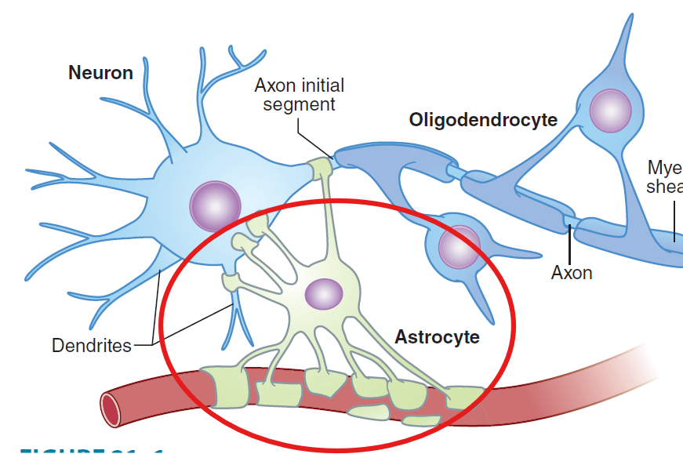
Figure 2. Astrocyte

B2. | OLIGODENDROCYTES
- Cells that wrap around the axons of projection neurons in the CNS forming the myelin sheath.
- Myelin sheath created by the oligodendrocytes insulates the axons and increases the speed of signal propagation.
- Damage to oligodendrocytes occurs in multiple sclerosis.

B3. | MICROGLIA
- Specialized macrophages derived from the bone marrow that settle in the CNS.
- Major immune defense system in the brain.
- Actively involved in neuroinflammatory processes in many pathologic states including neurodegenerative diseases.
- Synaptic pruning: Microglia engulf and eliminate synapses which is crucial for normal circuit development.
- Excessive microglia-mediated synapse elimination has been linked to schizophrenia and Alzheimer disease.

- BLOOD BRAIN BARRIER
- The blood-brain barrier (BBB) is a protective functional separation of the circulating blood from the extracellular fluid of the CNS that limits the penetration of substances, including drugs.
- This separation is accomplished by the presence of tight junctions between the capillary endothelial cells as well as a surrounding layer of astrocyte end-feet.
- Drugs must either be highly hydrophobic (or lipophilic) or engage specific transport mechanisms.
- Many nutrients including glucose and the essential amino acids, have specific transporters that allow them to cross the BBB.
L-DOPA | - A precursor of the neurotransmitter dopamine.  - Can enter the brain using an amino acid transporter.  - Orally administered L-DOPA can be used to boost CNS dopamine levels in the treatment of Parkinson disease.
Dopamine | - Cannot cross the BBB.
Table 1. L-DOPA & DOPAMINE

- Circumventricular organs
- Lack a normal BBB
- Examples:
- Area postrema vomiting center (Located on the Medulla).
- Regions that secrete neurohormones (Hypophyseal: Pituitary and hypothalamic gland) into the circulation.

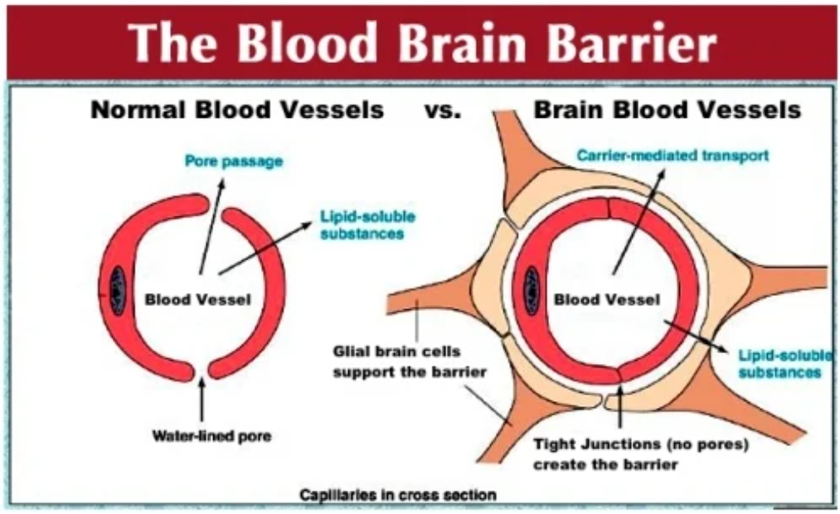
Figure 3. Blood Brain Barrier.
On the right side, the BBB is made up of tight junctions between the capillary endothelial cells as well as the surrounding layers of the astrocyte end-feet; Because of that, substances outside of the CNS cannot just enter the CNS because of this BBB.

- ION CHANNELS & NEUROTRANSMITTER RECEPTORS
- VOLTAGE-GATED CHANNELS
- Respond to changes in the membrane potential of the cell.
- Depends on the voltage of the membrane, it needs to reach a certain voltage for the membrane for the receptor to open. It needs to generate an action potential first before reaching the certain voltage to open the receptor.
- Highly concentrated on the initial segment of the axon, and along the length of the axon where they propagate the action potential to the nerve terminal.
- Many types of voltage-sensitive calcium and potassium channels on the cell body, dendrites, and initial segment, which act on a much slower time scale and modulate the rate at which the neuron discharges.
- For example, some types of Potassium channels opened by depolarization of the cell result in slowing of further depolarization and act as a brake to limit action potentials.
- Plant and animal toxin that target various voltage-gated ion channels have been invaluable for studying the functions of these channels.
- Neurotransmitters exert their effects on neurons by binding to two distinct classes of receptor:
- Ligand-gated channels, or ionotropic receptors.
- Metabotropic receptors
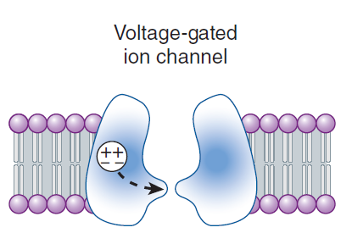
Figure 4. Voltage-gated ion channel.
A voltage sensor component of the proteins controls the gating (broken arrow) of the channel.

- LIGAND-GATED CHANNELS
- Consist of multiple subunit and binding of the neurotransmitter ligand directly opens the channel, which is an integral part of the receptor complex.
- Activation of these channels typically results in a brief (a few milliseconds to tens of milliseconds) opening of the channel.
- Responsible for fast synaptic transmission typical of hierarchical projection pathways in the CNS.
- Weakly sensitive to membrane potential.

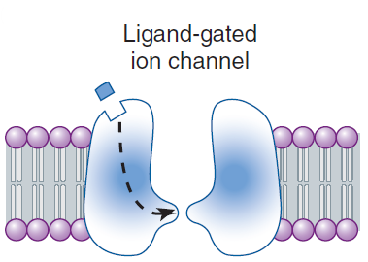
Figure 5. Ligand-gated ion channel.
The binding of the neurotransmitter to the ionotropic channel receptor controls the gating (broken arrow) of the channel.

- METABOTROPIC RECEPTORS
- Seven transmembrane G protein-coupled receptors (GPCRs).
- Binding of neurotransmitter to this type of receptor does NOT result in the direct gating of a channel.
- Binding to the receptor engages a G protein, which results in:
- Modulation of voltage gated channels (membrane-delimited pathways): G protein (often the βy subunit) interacts directly with a voltage-gated ion channel.
- In general, two types of voltage-gated ion channels are the targets of this type of signaling: calcium channels and potassium channels.

REMEMBER!

G protein INHIBITS CALCIUM CHANNEL inhibiting neurotransmitter release that occurs when presynaptic metabotropic receptors are activated.
G protein ACTIVATES K RECEPTORS post synaptic receptors because they activate K channels this results in slow post synaptic inhibition.

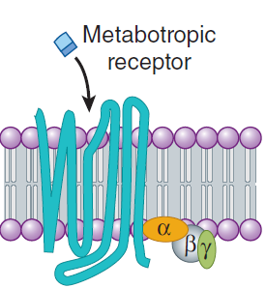
Figure 6. Metabotropic receptor.
G protein-coupled(metabotropic) receptor, which when bound, activates a heterotrimeric G protein.

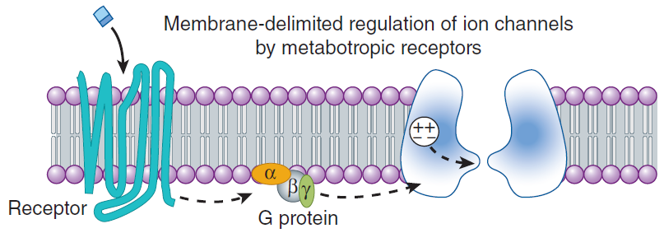
Figure 7. Membrane-delimited regulation of ion channels.
The activated G protein can interact directly to modulate an ion channel.

- Modulate voltage-gated channels less directly by the generation of diffusible second messengers (activates enzymes):
- It can activate an enzyme and the enzyme opens the channel.
- Example of this type of action is provided by the B adrenoceptor, which generates cAMP via the activation of adenylyl cyclase.
- Second messenger- mediated effects can occur over considerable distances.
- The effects of metabotropic receptor activation can last ten of seconds to minutes (more prolonged)
- Metabotropic receptors predominate in the diffuse neuronal systems.

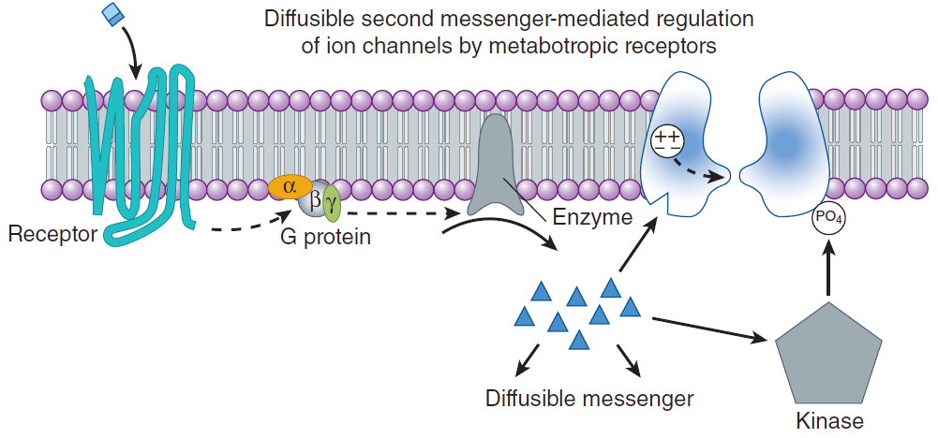
Figure 8. Diffusible second messenger-mediated regulation of ion channels by metabotropic receptors.
G protein can activate an enzyme that generates a diffusible second messenger, e.g., cAMP, which can interact with the ion channel or can activate a kinase that phosphorylates and modulates a channel.

- NATURAL TOXINS USED AS TOOLS FOR CHARACTERIZING ION CHANNELS

CHANNEL TYPES | MODE OF TOXIN ACTION | SOURCE | NOTES
VOLTAGE-GATED
Sodium Channels
Tetrodotoxin | Blocks channel from outside | Puffer fish | Caused by not properly cooked puffer fish which leads to paralysis because the sodium channel is blocked.
Batrachotoxin | Slows activation, shifts activation | Colombian Frog | If it slows the activation EXCITATION resulting to tetanic contractions or contraction of the muscles or even seizures because sodium channels are being activated.
Potassium Channels
Apamin | Blocks “Small Ca-activated” K channels | Honeybee
Charybdotoxin | Blocks “Big Ca-activated” K channel | Scorpion | If you block the big Ca-activated K channel leads to EXCITATION resulting in contraction of the muscles and seizures.
Calcium Channels
Omega conotoxin (ωCTX-GVIA) | Blocks N-type channel | Pacific cone snail
Agatoxin (ωAGAIVA) | Blocks P-type channel | Funnel web spider
LIGAND-GATED
Nicotinic Ach Receptor
a-Bungarotoxin | Irreversible antagonist | Marine Snake
GABA_{A} Receptor
Picrotoxin | Blocks channel | South Pacific Plant | GABA_{A} Receptor is blocked by picrotoxin and is an inhibitory NT.
Glycine Receptor
Strychnine | Competitive antagonist | Indian plant | Glycine is an inhibitory NT and seen in rat poison.
AMPA Receptor
Philanthotoxin | Blocks channel | Wasp | Excitatory receptor and if blocked will result in paralysis.
Table 2. Some toxins used to characterize Ion channels.

- THE SYNAPSE & SYNAPTIC POTENTIALS
Action potential propagation: down the axon of the pre synaptic neurons

Enters the synaptic terminal

Activates voltage-sensitive calcium channels in the membrane of the terminal

Calcium flows into the terminal thereby increasing intra-terminal calcium concentration

Promotes the fusion of synaptic vesicles with the presynaptic membrane

Neurotransmitter contained in the vesicles is released into the synaptic cleft

Diffuses to the receptors on the postsynaptic membrane.

- The neurotransmitter binds to its receptor and opens channels (either directly or indirectly) causing a brief change in membrane conductance (permeability to ions) of the postsynaptic cell.
- It has to be released, has to bind and should be terminated.
- After it’s termination it can be re-uptaken, diffuse or can be taken by glial cells to terminate the effect. Otherwise, there will be prolonged effect.
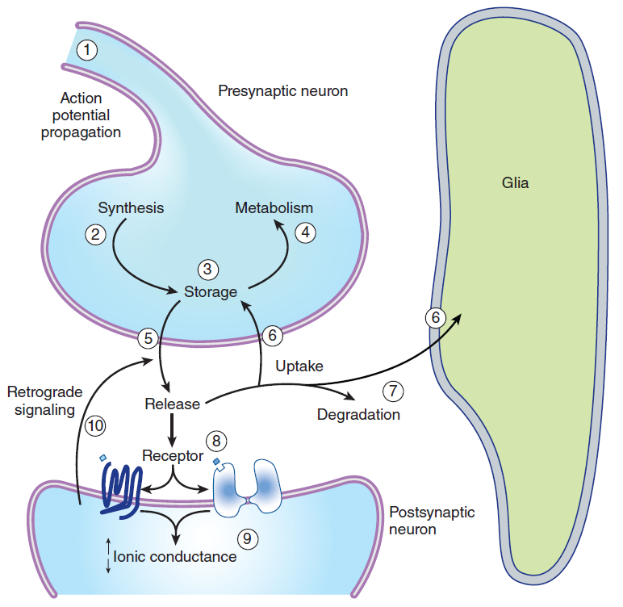
Figure 8. Synaptic Cleft.

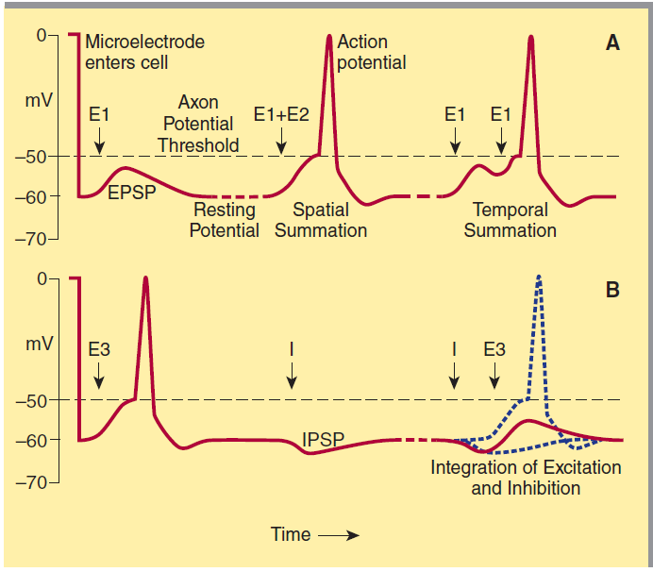
Figure 9. Postsynaptic potentials and action potential generation.
Figure A shows the voltage recorded upon entry of a microelectrode into a postsynaptic cell and subsequent recording of a resting membrane potential of −60 mV. Stimulation of an excitatory pathway (E1, left) generates transient depolarization called an excitatory postsynaptic potential (EPSP).
Simultaneous activation of multiple excitatory synapses (E1 + E2, middle) increases the size of the depolarization, so that the threshold for action potential generation is reached. Alternatively, a train of stimuli from a single input can temporally summate to reach the threshold (E1 + E2, right). Figure B demonstrates the interaction of excitatory and inhibitory synapses. On the left, a suprathreshold excitatory stimulus (E3) evokes an action potential. In the center, an inhibitory pathway (I) generates a small hyperpolarizing current called an inhibitory postsynaptic potential (IPSP). On the right, if the previously suprathreshold excitatory input (E3) is given shortly after the inhibitory input (I), the IPSP prevents the excitatory potential from reaching threshold.
- EXCITATORY POSTSYNAPTIC POTENTIAL (EPSP)
- Small depolarization or excitatory postsynaptic potential (EPSP) is recorded. This potential is due to the excitatory transmitter acting on an ionotropic receptor, causing an increase in cation permeability.
- As additional excitatory synapses are activated, there is a graded summation of the EPSPs to increase the size of the depolarization: SPATIAL SUMMATION.
- A repetitive firing of an excitatory input, the TEMPORAL SUMMATION of the EPSPs may also reach the action potential threshold.

- INHIBITORY POSTSYNAPTIC POTENTIAL (IPSP)
- When an inhibitory pathway is stimulated, the postsynaptic membrane is hyperpolarized owing to the selective opening of chloride channels, producing an Inhibitory Postsynaptic Potential (IPSP).
- Combination of an excitatory and inhibitory: cancel out.
- However, because the equilibrium potential for chloride is only slightly more negative than the resting potential (~ −65 mV), the hyperpolarization is small and contributes only modestly to the inhibitory action.
- Opening of the chloride channel during the IPSP makes the neuron “leaky” so that changes in membrane potential are more difficult to achieve.

- SITES OF DRUG ACTION
- Virtually all the drugs that act in the CNS produce their effects by modifying some step in chemical synaptic transmission.
- Transmitter-dependent actions can be divided into presynaptic and postsynaptic categories.

Figure 10. Schematic drawing of steps at which drugs can alter synaptic transmission.
(1) Action potential in propagation; (2) synthesis; (3) storage; (4) metabolism; (5) release; (6) reuptake; (7) degradation; (8) receptor for the transmitter; (9) receptor-induced increase or decrease in ionic conductance; (10) retrograde signaling.
- PRESYNAPTIC ALTERATION
- Drugs acting on the synthesis, storage, metabolism, and release of neurotransmitters fall into the presynaptic category:
Synaptic transmission can be depressed by blockade of transmitter synthesis or storage | RESERPINE depletes monoamine synapses of transmitters by interfering with intracellular storage.
Drugs can alter the release of transmitters | AMPHETAMINE induces the release of catecholamines from adrenergic synapses
CAPSAICIN causes the release of the peptide substance P (pain modulator) from sensory neurons.
TETANUS TOXIN blocks the release of transmitters (inhibitory glycine) resulting in spasticity.

Table 3. Drugs acting on the synthesis, storage, metabolism, and release of neurotransmitters.

- After a CNS transmitter has been released into the synaptic cleft, its action is terminated either by uptake or by enzymatic degradation.
- For neurotransmitters, there are uptake mechanisms into the synaptic terminal and also into surrounding neuroglia.
- No uptake mechanism has been found for any of the numerous CNS peptides, and it has yet to be demonstrated whether specific enzymatic degradation terminates the action of peptide transmitters.
A1. | COCCAINE
- Blocks the uptake of catecholamines at adrenergic synapses and thus potentiates the action of these amines.
- Amphetamines cause the release of catecholamines (e.g. norepinephrine, dopamine).
- Prolonged catecholamine in the synaptic area will stimulate sympathetic activities (e.g. increased BP, dilation, sweating).

A2. | ACETYLCHOLINE
- Inactivated by enzymatic degradation, NOT reuptake.
- Anticholinesterases block the degradation of acetylcholine and thereby prolong its action.
- Acetylcholinesterase inhibitors that block acetylcholinesterase are used in Alzheimer’s Disease so that acetylcholine will have a prolonged stay in the receptors.

- POSTYNAPTIC ALTERATION
- In the postsynaptic region, the transmitter receptor provides the primary site of drug action:
- Drugs can act either as neurotransmitter agonists.
- Such as the opioids, which mimic the action of enkephalin (pain modulators).
- Receptor antagonism/ blockade is a common mechanism of action for CNS drugs.
- Strychnine blocks the receptor for the inhibitory transmitter glycine leading to convulsions, illustrates how the blockade of inhibitory processes results in excitation.
- Drugs can also act directly on the ion channel of ionotropic receptors.
- Anesthetic ketamine blocks the NMDA subtype of glutamate ionotropic receptors by binding in the ion channel pore.
- Drugs can act at any of the steps downstream of the receptor.
- Methylxanthines, which can modify neurotransmitter responses mediated through the second-messenger cAMP
- At high concentrations, Methylxanthines elevate the level of cAMP by blocking its metabolism and thereby prolong its action.

- RETROGRADE SIGNALING
- The traditional view of the synapse is that it functions like a valve, transmitting information in one direction.
- However, it is now clear that the synapse can generate signals that feedback onto the presynaptic terminal to modify the transmitter release.
- Endocannabinoids are the best-documented example of such retrograde signaling.
- Example of this is the Cannabis/Marijuana which promote retrograde signaling.
- Postsynaptic activity leads to the synthesis and release of endocannabinoids, which then bind to receptors on the presynaptic terminal.
- Nitric oxide (NO) has long been proposed as a retrograde messenger, its physiologic role in the CNS is still not well understood.
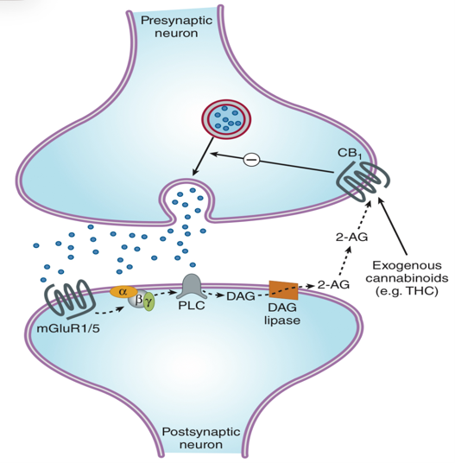
Figure 11. Retrograde signaling (Endocannabinoids)
- SELECTIVITY OF CNS DRUGS
- Two primary factors:
- Different neurotransmitters are released by different groups of neurons.
- These transmitters are often segregated into neuronal systems that subserve broadly different CNS functions.
- Some may act in the brainstem, cortex, and other specific areas of the brain.
- New drugs specifically act on specific receptors. Levodopa is an example which acts on the midbrain and basal ganglia.
- There is multiplicity of receptors for each neurotransmitter.
- For example, there are at least 14 different serotonin receptors.
- These receptors often have differential cellular distributions throughout the CNS, allowing for the development of drugs that selectively target particular receptor and CNS functions.

- CELLULAR ORGANIZATION OF THE BRAIN
- HIERARCHICAL SYSTEMS
- In sensory concept, it refers to the:
- First (receptors to spinal cord)
- Second (spinal cord to thalamus)
- Third (thalamus to the sensory area of the brain) Order Neuron
- In motor, it goes down from the pyramidal cells to the spinal cord, spinal cord to the anterior motor neuron going to the muscles.
- Include all the pathways directly involved in sensory perception and motor control
- Composed of large myelinated fibers that can often conduct action potentials at a rate of more than 50 m/s
- Uses IONOTROPIC RECEPTORS (FAST but short-lived transmission)
- Within each nucleus and in the cortex, there are two types of cells: Relay/projection neurons and local circuit neurons.
- Relay neurons: EXCITATORY (Glutamate)
- Local circuit neurons: INHIBITORY (GABA or Glycine)

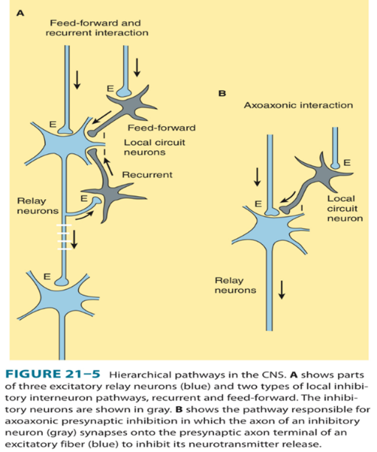

Figure 12. Hierarchical Pathways in the CNS.
A shows parts of three excitatory relay neurons (blue) and two types of local inhibitory interneuron pathways, recurrent and feedforward. The inhibitory neurons are shown in gray. B shows the pathway responsible for axoaxonic presynaptic inhibition in which the axon of an inhibitory neuron (gray) synapses onto the presynaptic axon terminal of an excitatory fiber (blue) to inhibit its neurotransmitter release

- NON-SPECIFIC OR DIFFUSE NEURONAL SYSTEMS
- Neuronal systems containing many of the other neurotransmitters, including monoamines and acetylcholine
- These neurotransmitters are produced by only a limited number of neurons whose cell bodies are located in small discrete nuclei, often in the brain stem.
- Noradrenergic cell bodies in locus coeruleus located in the caudal pontine central gray matter from the limited nuclei, these neurons project widely and diffusely projecting throughout the brain and spinal cord.
- Because the axons from these diffusely projecting neurons are fine and unmyelinated they conduct very slowly, at about 0.5 m/s
- Axons branch repeatedly and are extraordinarily divergent
- Branches from the same neuron can innervate several functionally different parts of the CNS, synapsing onto and modulating neurons within the hierarchical systems.
- Most neurotransmitters utilized by diffuse neuronal systems, including norepinephrine, act predominantly on metabotropic receptors and therefore initiate long-lasting synaptic effects.
- Most diffuse or non-specific neuronal system uses METABOTROPIC RECEPTORS (Slower but more prolonged).

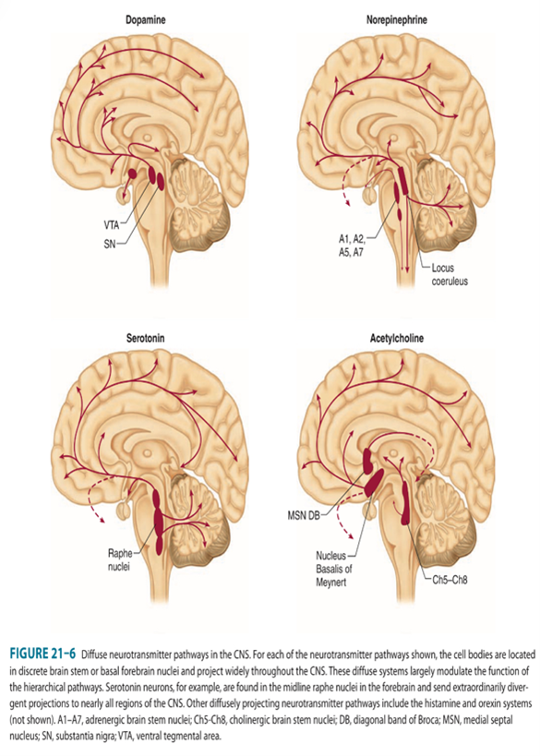
Figure 13. Diffuse neurotransmitter pathways in the CNS.
For each of the neurotransmitter pathways shown, the cell bodies are located in discrete brain stem or basal forebrain nuclei and project widely throughout the CNS. These diffuse systems largely modulate the function of the hierarchical pathways. Serotonin neurons, for example, are found in the midline raphe nuclei in the forebrain and send extraordinarily divergent projections to nearly all regions of the CNS. Other diffusely projecting neurotransmitter pathways include the histamine and orexin systems (not shown). A1–A7, adrenergic brain stem nuclei; Ch5–Ch8, cholinergic brain stem nuclei; DB, diagonal band of Broca; MSN, medial septal nucleus; SN, substantia nigra; VTA, ventral tegmental area.

REMEMBER!

HIERARCHICAL NEURONAL SYSTEM
IONOTROPIC RECEPTORS (FAST but short-lived transmission)
NON-SPECIFIC OR DIFFUSE NEURONAL SYSTEM
METABOTROPIC RECEPTORS (SLOWER but more prolonged)

- CENTRAL NEUROTRANSMITTER
- Criteria for neurotransmitter identification:
- Localization: A suspected transmitter must reside in the presynaptic terminal of the pathway of interest.
- Release: A suspected transmitter must be released from a neuron in response to neuronal activity and in a calcium-dependent manner.
- Synaptic Mimicry: Application of the candidate substance should produce a response that mimics the action of the transmitter released by nerve stimulation, and application of a selective antagonist should block the response.

- AMINO ACID NEUROTRANSMITTERS
A1. | GLUTAMATE
- Major excitatory neurotransmitter in the CNS.
- Excitatory synaptic transmission is mediated by glutamate.
- Cleared by glutamate transporters present on surrounding glia.
- Converted to glutamine-by-glutamine synthetase
- The high concentration of glutamate in synaptic vesicles is achieved by the vesicular glutamate transporter (VGLUT)
- Activates BOTH inotropic and metabotropic receptor.
- Glutamate Ion Receptors (Based on the action of selective agonist):
- a-amino-3-hydroxy-5-methylisoxazole-4-propionic acid
(AMPA)
- Kainic acid (KA)
- N-methyl-d-aspartate (NMDA)

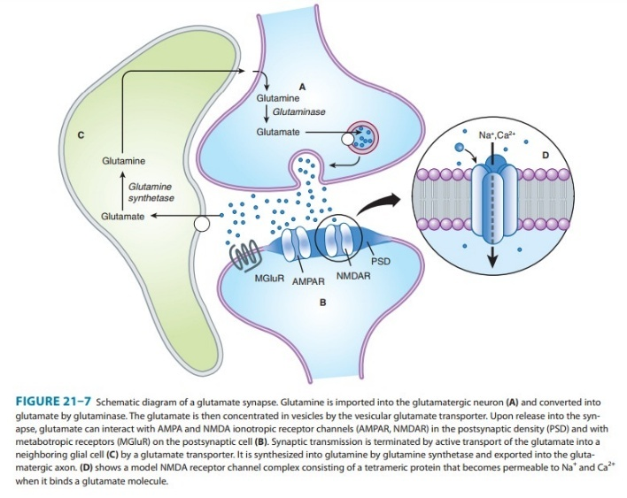
Figure 14. Schematic diagram of a glutamate synapse. Glutamine is imported into the glutamatergic neuron (A) and converted into glutamate by glutaminase. The glutamate is then concentrated in vesicles by the vesicular glutamate transporter (VGLUT). Upon release into the synapse, glutamate can interact with AMPA and NMDA ionotropic receptor channels (AMPAR, NMDAR) and with metabotropic receptors (mGluR) on the postsynaptic cell (B). Synaptic transmission is terminated by active transport of the glutamate into a neighboring glial cell (C) by a glutamate transporter. It is converted into glutamine-by-glutamine synthetase and transported back into the glutamatergic axon terminal.

AMPA RECEPTORS (a-amino-3-hydroxy-5-methylisoxazole-4-propionic acid)
- Present on all neurons, are heterotetramers assembled from four subunits (GluA1-GluA4).
- Majority of AMPA receptors contain the GluA2 subunit and are permeable to Na and K, but NOT to calcium.
- AMPA receptors, typically present on inhibitory interneurons, lack the GluA2 subunit and are also permeable to calcium.
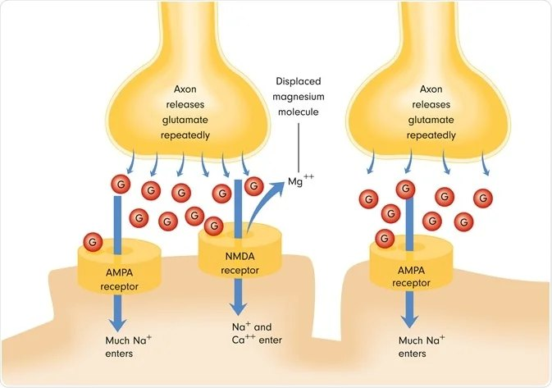
Figure 15. AMPA Receptors.
Glutamate first binds to AMPAR, which conducts sodium through the channel to depolarize the neuron. The NMDAR, however, is blocked by a Magnesium ion, which requires sufficient depolarization to be removed. The Na+ repels the Mg2+, removing the blockage and effectively allowing Ca2+ into the cell, engaging in various chemical cascades to maintain neural health.
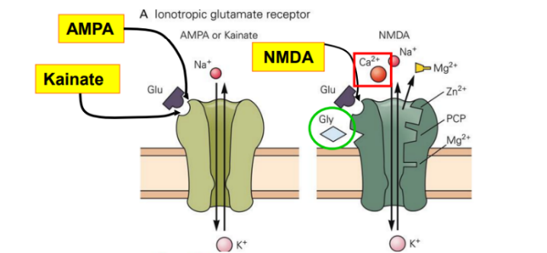
Figure 16. Ionotropic glutamate receptor

NMDA (N-methyl-d-aspartate)
- Are as ubiquitous as AMPA receptors.
- Present on essentially all neurons in the CNS
- All NMDA receptors require the presence of the subunit GluN1.
- Contains one or two GluN2 subunits (GluN2A- GluN2D)
- All NMDA receptors are highly permeable to Ca2+ as well as to Na+ and K+
- Receptor activation does not occur at resting membrane potential (NMDA receptor pore is blocked by extracellular Mg2+)
- These receptors do NOT easily open due to the blockage effect of Magnesium. Action Potential should reach a certain voltage for magnesium to be expelled.
- Three Requirements for NMDA: (FAMILIARIZE!)
- Glutamate must bind the receptor
- Glycine must bind the receptor
- Membrane must be depolarized to expel Magnesium

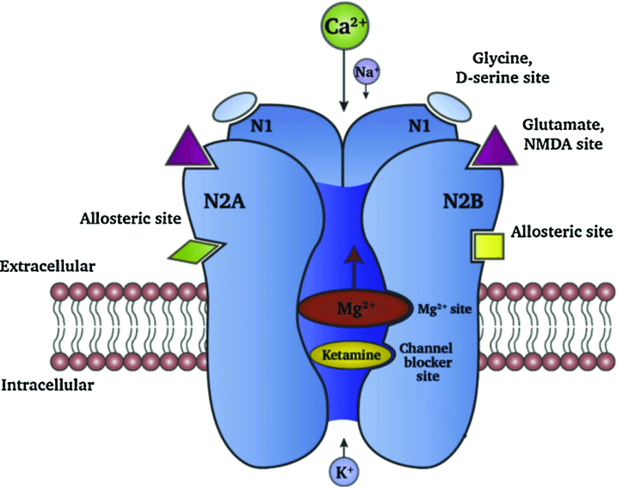
Figure 17. NMDA Receptor.
The NMDA receptor comprises of two N1 sub-units and two N2A/N2B, or one N2A and one N2B subunit. Ketamine binds within the channel of the NMDA receptor and acts as a non-competitive antagonist of the NMDA receptor. Inhibition of the NMDA receptor by ketamine prevents the influx of Ca 2+ and/ or Na + ions thus preventing neuronal membrane depolarization. This decreases the probability of neuronal ring, preventing further propagation of the neuronal signal, neurotransmitter release or downstream signaling mechanisms.

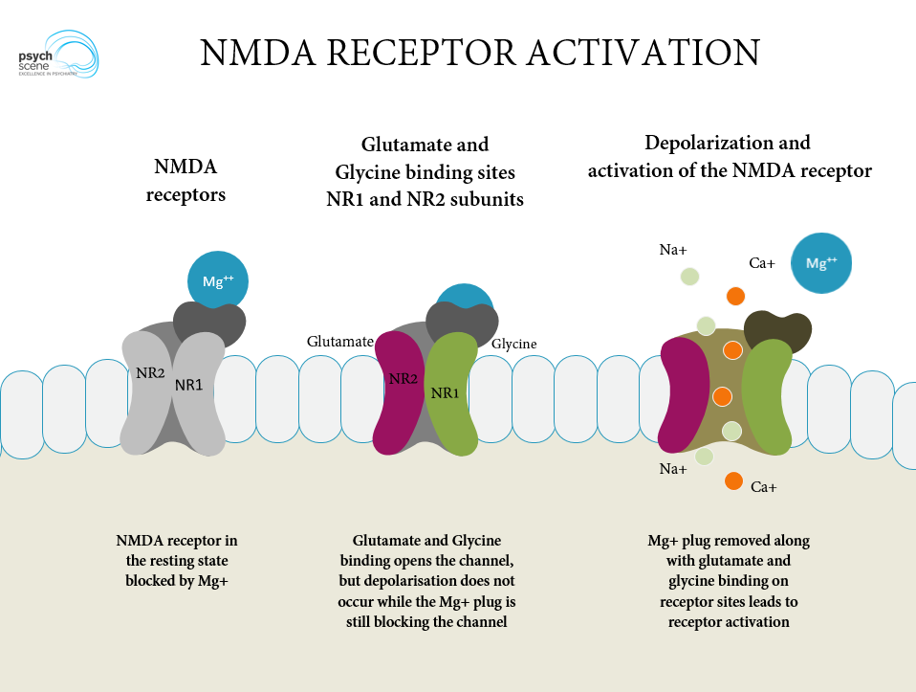
Figure 18. NMDA Receptor Activation.

KAINATE RECEPTORS
- Expressed at high levels in the hippocampus, cerebellum, and spinal cord.
- Not as uniformly distributed as AMPA.
- Formed from a number of subunit combinations (GluK1–GluK5)
- Similar to AMPA receptors, Kainate receptors are permeable to Na+ and K+.
- Some subunit combinations can also be permeable to Ca2+
- Domoic acid, a toxin produced by algae and concentrated in shellfish, is a potent agonist at Kainate and AMPA receptors. This toxin causes Dementia (memory loss).
- Kainate acts on the hippocampus (memory).
A2. | GLYCINE
- GABA and glycine are inhibitory NTs, which are typically released from local interneurons.
- Glycine is restricted to the spinal cord and brain stem, whereas interneurons releasing GABA are present throughout the CNS.
- Glycine receptors are pentameric structures that are selectively permeable to Cl-.
- Strychnine, which is a potent spinal cord convulsant and has been used in some rat poisons, selectively blocks glycine receptors.
- Used in rat poisons
A3. | GABA
- 2 main types:
- Gaba-A (Fast Component):
- GABA-A receptors are ionotropic receptors and like glycine receptors, are pentameric structures that are selectively permeable to Chloride.
- These receptors are selectively inhibited by picrotoxin and bicuculine, both of which cause generalized convulsions.
- GABAB (Slow Component):
- GABA-B receptors are metabotropic receptors that are selectively activated by the antispastic drug Baclofen.
- These receptors are coupled to G proteins that, depending on their cellular location, either inhibit Ca2+ channels or activate K+ channels.
- The GABA-B component of the inhibitory postsynaptic potential is due to a selective increase in K+ conductance. This inhibitory postsynaptic potential is long-lasting and slow because the coupling of receptor activation to K+ channel opening is indirect and delayed.
A4. | ACETYLCHOLINE
- First compound to be identified pharmacologically as a transmitter in the CNS.
- Most CNS responses to acetylcholine are mediated by a large family of G protein-coupled muscarinic receptors
- Acetylcholine causes slow inhibition of the neuron by activating the M2 subtype of receptor, which opens K+ channels.
- Slow excitation that in some cases is mediated by M1 receptors by decreasing the membrane permeability to potassium.
- CNS nuclei of acetylcholine neurons project to neostriatum, the medial septal nucleus, and the reticular formation that appear to play an important role in cognitive functions, especially memory.
- Dementia of Alzheimer’s type is reportedly associated with a profound loss of cholinergic neurons.
REMEMBER!
AMINO ACID NUEROTRANSMITTERS (G³A)
GLUTAMATE
GLYCINE
GABA
ACETYLCHOLINE

RECEPTOR | NOTES
AMPA RECEPTORS (a-amino-3-hydroxy-5-methylisoxazole-4-propionic acid) | - Contain the GluA2 subunit and are permeable to Na and K, but NOT to calcium.
NMDA (N-methyl-d-aspartate) | - Highly permeable to Ca2+ as well as to Na+ and K+
KAINATE RECEPTORS | - Kainate receptors are permeable to Na+ and K+.
Table 4. Summary on Amino acid Neurotransmitter Receptors.

- MONOAMINE NEUROTRANSMITTERS
- Monoamines include the catecholamines (Dopamine and Norepinephrine) and 5-hydroxytryptamine (Serotonin).
- CNS stimulants cocaine and amphetamine appear to act primarily at catecholamine synapses.
- Cocaine blocks the reuptake of dopamine and norepinephrine.
- Amphetamines cause presynaptic terminals to release these transmitters.
B1. | DOPAMINE
- Substantia nigra neostriatum link: therapeutic action of the anti-parkinsonism drug levodopa.
- Ventral tegmental-limbic structure link: the therapeutic action of the antipsychotic drugs.
- Dopamine-containing neurons in the ventral hypothalamus play an important role in regulating pituitary function.
- 5 dopamine receptors have been identified, and they fall into 2 categories:
- D1-like (D1 and D5)
- D2- like (D2, D3, D4)
- All dopamine receptors are METABOTROPIC.
- Dopamine generally exerts a slow inhibitory action on CNS neurons by opening potassium channels via the Gi coupling protein.
- Metabotropic action is indirect and slow.
B2. | NOEPINEPHRINE
- Noradrenergic neurons are located in the locus ceruleus or the lateral tegmental area of the reticular formation.
- All noradrenergic receptor subtypes are METABOTROPIC.
- In many regions of the CNS, norepinephrine actually enhances excitatory inputs by both indirect and direct mechanisms:
- Indirect mechanism involves disinhibition: inhibitory local circuit neurons are inhibited.
- Direct mechanism blockade of potassium conductance that slows neuronal discharge mediated by either α1 or β Receptors.
- Norepinephrine can hyperpolarize (inhibits neurons) by increasing potassium conductance- mediated by α2 receptors and has been characterized most thoroughly on locus coeruleus neurons.
- Norepinephrine enhances excitatory inputs on by both indirect and direct mechanisms.
- Indirect mechanism: Disinhibitory local circuit neurons inhibited.
- Direct mechanism: Blockade of potassium conductance that slow neuronal discharge.
- Facilitation of excitatory synaptic transmission is in accordance with many of the behavioral processes thought to involve noradrenergic pathways.
  - E.g. attention and arousal.

B3. | 5-HYDROXYTRYPTAMINE
- From midline raphe nuclei of the pons and upper brain stem projects diffusely to other areas.
- All receptors are METABOTROPIC except 5-HT3 (ionotropic).
- Ionotropic 5-HT3 receptor exerts a rapid excitatory action at a very limited number of sites in the CNS.
- In most areas of the CNS, 5-HT has a strong inhibitory action mediated by 5-HT1A receptors and is associated with membrane hyperpolarization caused by an increase in potassium conductance.
- Some cell types are slowly excited by 5-HT owing to its blockade of potassium channels via 5-HT2 or 5-HT4 receptors.
- Both excitatory and inhibitory actions can occur on the same neuron.
- 5-HT has been implicated in the regulation of virtually all brain functions, including perception, mood, anxiety, pain, sleep, appetite, temperature, neuroendocrine control, and aggression.
B4. | HISTAMINE
- Exclusively made by neurons in the tuberomammillary nucleus (TMN) in the posterior hypothalamus.
- These neurons project widely throughout the brain and spinal cord where they modulate arousal, attention, feeding behavioral and memory.
- Histamine receptors (H1 to H4) are METABOTROPIC.
- Centrally acting antihistamines are generally used for their sedative properties.
- Diphenhydramine (Benadryl®)
- Meclizine (Bonamine®)
- Levocetirizine
- Antagonism of H1 receptors is a common side effect of many drugs including some tricyclic antidepressants and antipsychotics.
- Patients on antidepressants drugs: side effects is sedation.
REMEMBER!
MONOAMINE NUEROTRANSMITTERS (DNSH)
DOPAMINE
NOREPINEPHRINE
SEROTONIN
HISTAMNE

- NEUROPEPTIDES
- Unlike the classical neurotransmitters which are packaged in small synaptic vesicles, neuropeptides are generally packaged in large, dense core vesicles.
- Large proteins compared to neurotransmitter.
- Released neuropeptides may act locally or may diffuse long distances and bind to distant receptors.
- Most neuropeptide receptors are METABOTROPIC and, like monoamines, primarily serve modulatory roles in the nervous system.
- Substance P is contained in and released from small unmyelinated primary sensory neurons in the spinal cord and brain stem and causes a slow excitatory postsynaptic potential in sensory fibers that are known to transmit noxious stimuli.
- Inhibit Substance P: reduces pain stimuli

C1. | OREXIN
- Are peptide neurotransmitters produced in neurons in the lateral and posterior hypothalamus.
- Project widely throughout the CNS.
- Are also called hypocretins due to the near-simultaneous discovery by two independent laboratories.
- Released from large, dense core vesicles and binds to two G-protein coupled receptors.
- Orexin neurons also release glutamate and are thus excitatory.
- The orexin system projects widely throughout the CNS to influence physiology and behavior. In particular, orexin neurons exhibit firing patterns associated with wakefulness and project to and activate monoamine and acetylcholine neurons involved in sleep-wake cycles.
- Orexin affects the circadian rhythm.
- Animals lacking orexin or its receptors have narcolepsy and disrupted sleep-wake patterns.
- Orexin is important in sleep – wake patterns
- In addition to promoting wakefulness, the orexin system is involved in energy homeostasis, feeding behaviors, autonomic function, and reward.
- Some of the sleeping pills can inhibit orexin.

INOTROPIC | METABOTROPIC
HIERARCHICAL NEURONAL SYSTEM | NON-SPECIFIC OR DIFFUSE NEURONAL SYSTEM
GABA A | GABA B
 | Dopamine
 | Norepinephrine
 | Serotonin except 5-HT3 (ionotropic).
 | Histamine
 | Neuropeptide receptors
Table 5. Summary on Inotropic or Metabotropic receptors.

- OTHER SIGNALING SUBSTANCES
D1. | ENDOCANNABINOIDS
- Δ-tetrahydrocannabinol (Δ – THC) affects the brain mainly by activating a specific cannabinoid receptor, CB1.
- Endogenous brain lipids, including anandamide and 2-arachidonylglycerol (2-AG) are CB1 ligands.
- 2-AG and CB1 are not stored but instead are rapidly synthesized by neurons in response to calcium influx or activation of metabotropic receptors (e.g., by acetylcholine and glutamate).
- Endogenous cannabinoids can function as retrograde synaptic messengers:
- They are released from postsynaptic neurons and travel backward across synapses, activating CB1 receptors on presynaptic neurons and suppressing transmission release.
- Cannabinoids may affect memory, cognition, and pain perception by this mechanism.

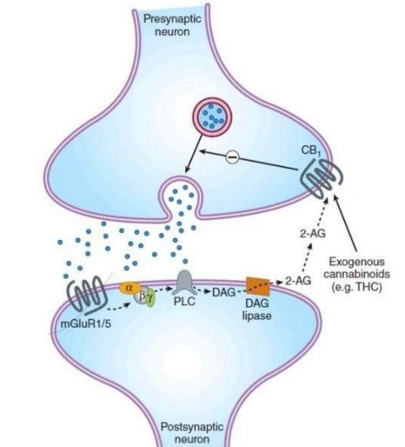
Figure 19. Endogenous cannabinoids system
Activation of postsynaptic group I metabotropic glutamate receptors (mGluR1/5) leads to the G protein mediated membrane delimited activation of phospholipase C (PLC) that produces the second messenger’s inositol trisphosphate (IP3, not shown) diacylglycerol (DAG). DAG can then be converted to the endogenous cannabinoid 2-arachidonoylglycerol (2AG) by DAG lipase. 2-AG is then released by unknown mechanisms to diffuse across the synaptic cleft where it acts as a full agonist at CB₁ cannabinoid receptors on the presynaptic terminals. Activation of CB₁ receptors by either endocannabinoids or exogenous cannabinoids such as Δ⁹ tetrahydrocannabinol (THC) results in the inhibition of presynaptic neurotransmitter release.
D2. | NITRIC OXIDE
- The CNS contains a substantial amount of nitric oxide synthase (NOS) within certain classes of neurons.
- This neuronal NOS is an enzyme activated by calcium-calmodulin.
- Activation of NMDA receptors, which increases intracellular calcium, results in the generation of nitric oxide.
- Nitric oxide diffuses freely across membranes to be a retrograde messenger that enhances glutamate release.
- Act on vascular smooth muscle- Potent vasodilator.

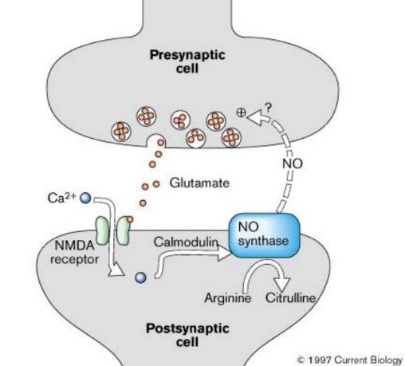
Figure 20. Synaptic plasticity: Nitric Oxide
NO acts as a retrograde messenger, the Ca²⁺ binds to calmodulin and activates NO synthase, which converts arginine to NO and citrulline. NO then diffuses to the presynaptic terminal, leading to enhanced transmitter release.
D3. | PURINES
- Receptors for purines, particularly adenosine, ATP, UTP, and UDP, are found throughout the body, including the CNS.
- High concentrations of ATP are found in and released from catecholaminergic synaptic vesicles, and ATP may get converted to adenosine extracellularly by nucleotidases.
- Adenosine in the CNS acts on metabotropic A1 receptors.
- Presynaptic A1 receptors inhibit calcium channels and inhibit release of both amino acid and monoamine transmitters.
- ATP co-released with other neurotransmitters can bind to two classes of receptors:
- The P2X family ATP receptors include nonselective ligand-gated Cation channels.
- P2Y family which is metabotropic.
- The physiologic roles for ATP co-release remain elusive, but pharmaco-logical studies suggest these receptors are involved in memory, wakefulness, and appetite and may play roles in multiple neuropsychiatric disorders.

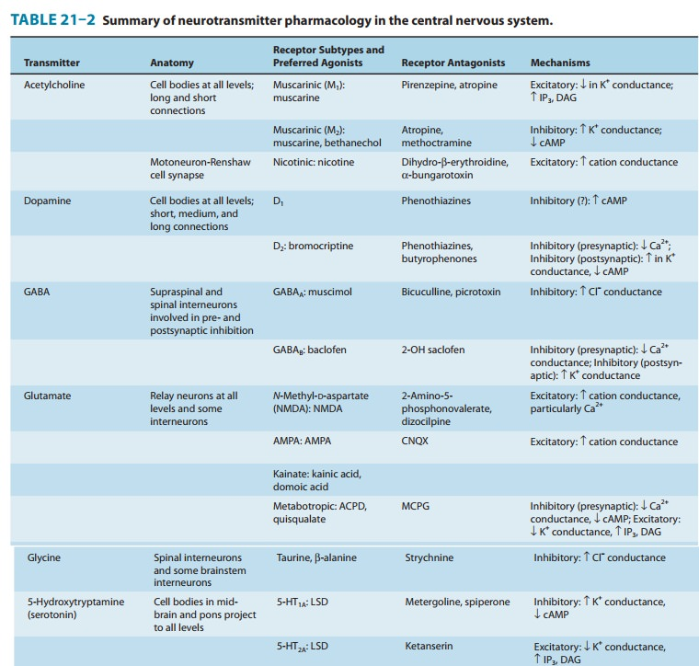
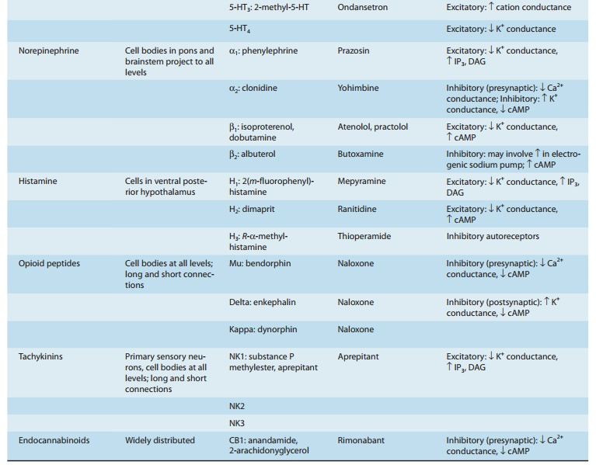

- REFERENCES
- Dr. Hiyadan’s PowerPoint
- Vanderah, T. W. (2023). Katzung’s Basic and Clinical Pharmacology, 16th Edition. McGraw Hill Professional.

- CHECKPOINT

